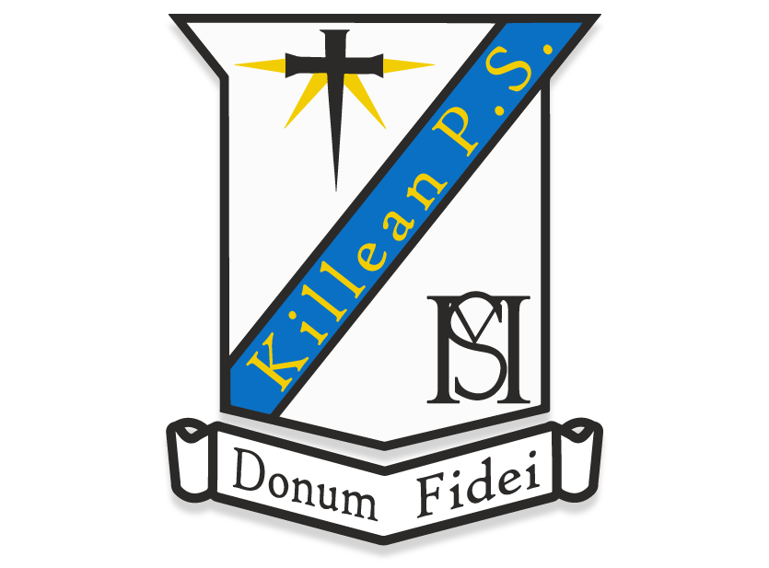

Dear Parents, Students and Friends of St Michael’s Primary School, Killean,

Please see below the instructions for downloading our school app by going directly to the App Store or Google Play Store.

Open the App Store on your Apple device or the Play Store on your Android device.

In the search bar, type Primary365
Look out for this icon (right) in the search results.
Press Get or Install.

1

Open the app and connect to your school by clicking the + button.
Enter the location where the school is located – Killean
Click ‘Continue’ to see our school

Tick here and click the Save icon in top right corner

2

Choose your Profile to receive notifications on your device.

For example, Parents select the Parent option and then tick the
Class(es) and/or Interest Group of your child.

Press the Save button to finish the set up.
When asked if you wish to allow Notifications, click ‘Yes’ or ‘Allow.’

You can revisit the Profile at any time to edit your selection by clicking on the Menu icon in the top right corner of the main screen.(a small person, three lines or dots)

3

