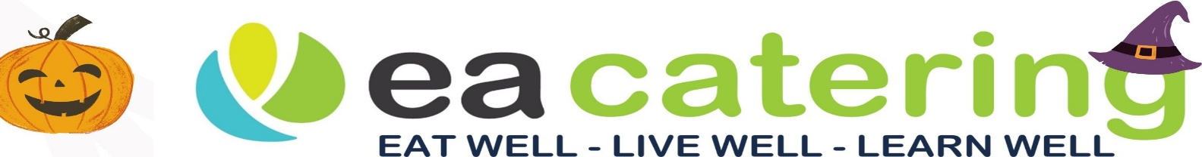

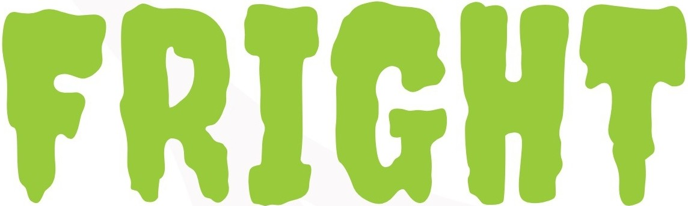
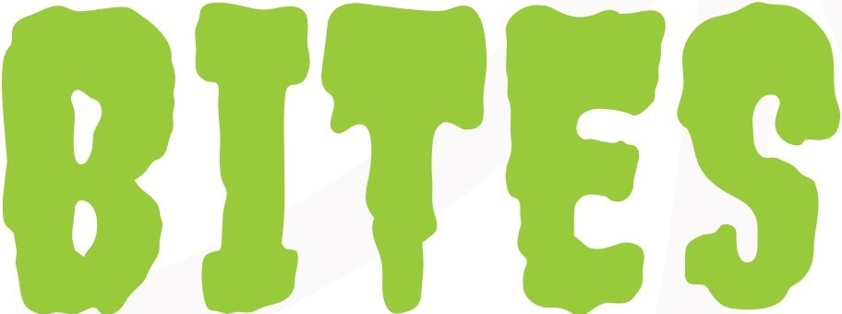

HALLOWEEN MENU

Goblins Fingers or Googly eyes
Sausages Chicken Nuggets

WITH

Monster Mash
or
Witches Broomsticks
or
Creepy Crunch

Mash Potato Chips Fresh Salad

AND

Eyes of Newt
Peas
Zombies Eyeballs
Beans

AND TO FINISH

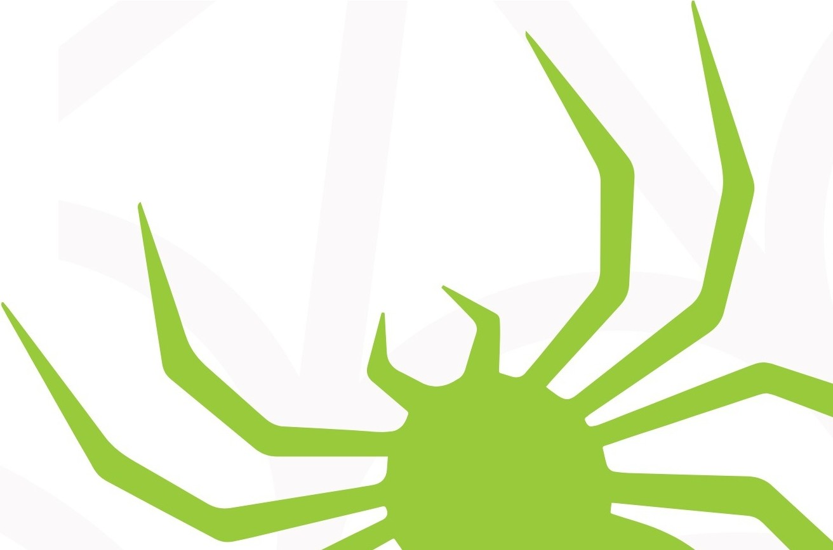
Zombies Brain & I scream!!!
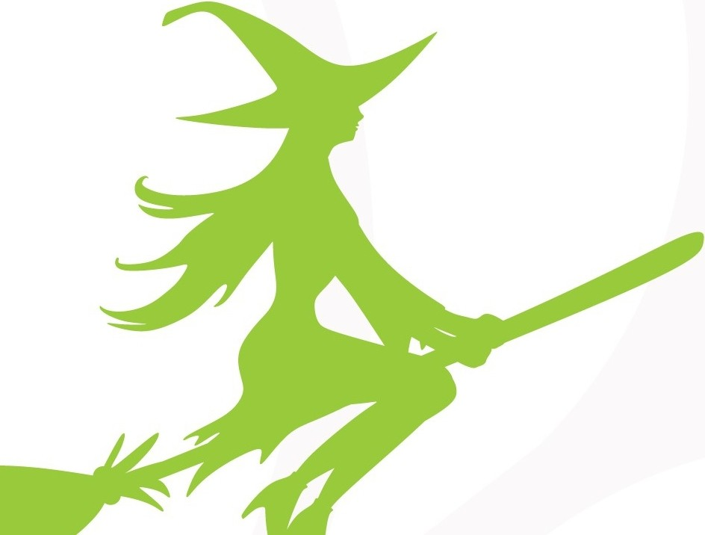
Jelly, Ice Cream, Ice lolly

