St. Michael’s Primary School, Killean

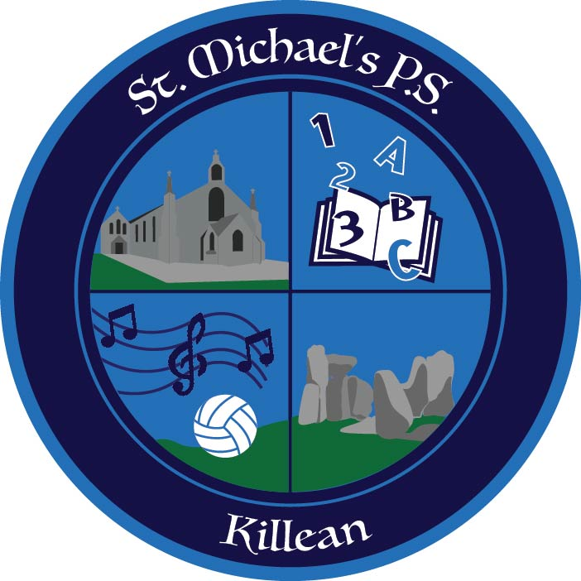

Fire Safety Policy

Agreed by Governing Body
Review Date
Review Schedule
Person(s) Responsible | Principal
Signed (Chair of Governing Body)

Aims
It is the overall aim of St. Michael’s Primary School to minimise the risks to pupils, staff and employees which may arise from fire. This will be achieved by working with St. Michael’s School to ensure precautions are taken to avoid fires occurring and by ensuring that procedures for minimising the effects of an outbreak of fire and evacuating the premises are in place.

Overall Responsibility for Fire Safety Matters
The Principal is appointed as the fire safety manager for the school and will have overall responsibility for fire safety matters at the school. He will co-ordinate the implementation of fire safety measures, ensure that staff and pupil training takes place and monitor the standard of fire precautions maintained. He will also ensure that a fire evacuation drill is undertaken at least twice per year, that fire action notices are kept up to date and that fire safety equipment is being maintained.

The School Fire Evacuation Procedure
Notices displaying the school fire procedure will be displayed at each fire alarm call point, in each room and general areas. (appendix A)

Responsibility of all School Staff
All school staff are responsible for maintaining a high standard of fire precautions in areas under their control or influence. In particular, staff should ensure that they are fully aware of the fire procedure. They should ensure that door vision panels and fire exits are kept clear and fire doors are kept shut. They should also ensure that pupils for whom they are responsible are informed of the fire procedure.

Fire Risk Assessment
The school will carry out a fire risk assessment for the building. The fire risk assessments identify who will be at risk if there is a fire, where people may be working and who else may be at risk, either in the premises or nearby, such as members of the public, visiting contractors, etc., and where these people are likely to be located. The fire risk assessment will be reviewed and amended on a six-month cycle to see if it is either no longer valid or if any changes are planned, such as:
- any structural changes (alterations to the layout of the premises, erection of partitions, refurbishment etc.) which may affect the spread of fire;
- any change to the use of the premises which may affect the risk rating;
- any change to work processes or work equipment which may introduce new fire hazards;
- any change to the numbers of people using the premises to ensure that escape routes can accommodate the numbers safely.

Fire Training and Evacuation Drills
All employees shall be provided with adequate fire safety information and training. All staff, whether temporary or permanent, will have the fire procedure explained to them, together with information on the location of the fire alarm call points, the sound of the fire alarm and the location of the escape routes, exits and assembly points. It is the responsibility of the fire safety manager to ensure this instruction is given in accordance with the Checklist below.*

As part of their induction training, the Fire Safety Manager shall provide new employees on the day on which they commence work with information (emergency plan) on the fire safety and emergency evacuation arrangements that apply to their workplace.

*This information shall include: -
- what to do if they discover a fire or hear the fire alarm, what the fire alarm sounds like
- means of raising the alarm, siting of nearest alarm point and nearest fire extinguisher;
- showing them the fire evacuation routes, emergency exits, means of operating any exit
- devices such as panic bars, and the fire assembly point;
- an explanation of the reporting arrangements in the event of a fire or drill.
- an explanation of the importance of keeping fire doors shut, escape routes clear of • combustible materials, and good housekeeping etc. as detailed in duties of employees.

Managers shall bring to the attention of employees a copy of the emergency plan detailing the evacuation procedures for the premises. They must ensure that employees under their control comply with the emergency fire evacuation procedures and fire precautions.
The fire safety manager will also ensure that all fire safety records are maintained and are available for inspection by any enforcement authority. The Fire Safety Manager will provide a written report to the Governing Body on an annual basis.

Personalised Emergency Evacuation Plans (PEEPs)
In the case of any person using the site having a condition that may prevent them from evacuating quickly and safely, the school will devise a PEEP for that person.

Maintenance of Fire Doors, Fire Exit Doors, Fire Equipment and Systems
Fire extinguishers, fire alarm systems and emergency lighting are maintained under a central contract administered by the Education Authority. However, St. Michael’s Primary School, Killean will carry out the following tests on the systems and precautions between maintenance visits:

System | Frequency | Method of Test
Fire Alarm | Weekly | Test key operation of different call point each week in rotation
Fire Alarm | Daily | Visual check of panel for fault indications
Emergency Lighting | Monthly | Operation of test switch or circuit breaker and check that light illuminates
Fire extinguishers, hose reels, fire blankets etc. | Weekly | Check that seals are intact, equipment has not been removed or tampered with and annual inspection and maintenance is in date.
Fire Doors | Weekly | Check that doors are closing fully and, where fitted, latches are operating
Corridors, Escape Routes and  Fire Exit Doors | Daily | Check exit doors are unlocked and that escape routes are free of obstruction
Fire Exit Doors | Weekly | Check that doors are opening freely and that emergency exit fittings are operating correctly.

Appointment and Duties of Fire Marshals
The school will appoint a number of staff as fire marshals. There is a Senior Fire Marshal (Principal) and Deputy First Marshal (Building Supervisor). These staff will have responsibility for ensuring that all areas of the school have been evacuated and that this is reported to the senior fire marshal in charge of the evacuation (see appendix b). All teachers are fire marshals. They take responsibility for ensuring their class reach the fire evacuation point in a safe and timely manner.

Raising the alarm
In the event of alarm failure a hand bell will be rung in order to raise the alarm. A hand bell will be kept in the staffroom.

Calling the Fire Brigade
It is the school policy that the fire brigade will be called on any confirmed outbreak of fire. The school’s office staff are responsible for calling the fire brigade when the alarm is sounded. Where the alarm is raised by the school’s automatic smoke detection the school office/secretary will call the fire brigade if a fire is confirmed, or within 60 seconds of the alarm being raised if a false alarm is not confirmed.

Meeting the Fire Brigade
The fire safety manager is responsible for ensuring that one member of staff is available to meet the fire brigade on arrival and in their absence there is a member of staff to deputise for them.
Events taking place out of school hours such as school plays or external lettings where events are organised outside normal school hours, or by outside organisations, it is the responsibility of the member of staff organising the event or arranging the letting to ensure that the Fire Safety Manager is consulted and appropriate precautions including arrangements for evacuation and calling the fire brigade are put in place.
Notices
All fire exit routes will be signed by clear signs with directional arrows. (Running Man)

Records
Fire Alarm Tests / Practice Fire drills / Maintenance logs etc. will be the responsibility of the Building Supervisor. These records will be kept in the main office.

St. Michael’s P.S. Killean Appendix A
FIRE SAFEGUARDING
Any person discovering a fire should:
Break glass at nearest Fire Alarm Point
The building should be evacuated as follows:
- Resource Room/Dinner Hall exit through main exit or either fire
Exit door
- Primary 1 and Primary 2/3 exit through ‘back door’ in classroom.
- Primary 3/4 exit through secondary entrance external doors.
- Library/ICT suite exit through fire doors at the top of the hall.
- Mobile classrooms exit through fire exit doors in each classroom and proceed to Fire Assembly Area
- Staffroom exit through Main Entrance
- Principal Office & Main Office exit through Main Entrance
- If any exit is in an area affected by fire use the nearest alternative exit
The main assembly point is in the main car park to the front of school. Fire Safety Manager to put cones in front of the gates. Children to then move safely to ‘the playing field’ adjacent to the school.
Secretary to take registers. Class teachers should take their class register roll call and supervise their class until the all clear is given
Building Supervisor to check pupil toilets and School Meals Kitchen
Do not return to the school building for any reason until
instructed to do so.

Appendix B

Role | Person Responsible | In Case of Absence
Fire Safety Manager | Principal | Senior Teacher
Fire Marshals | Principal/Building Supervisor/Teachers | SLMT
Calling Fire Brigade | Office Staff | Building Supervisor
Meeting the Fire Brigade | Principal | Senior Teacher

